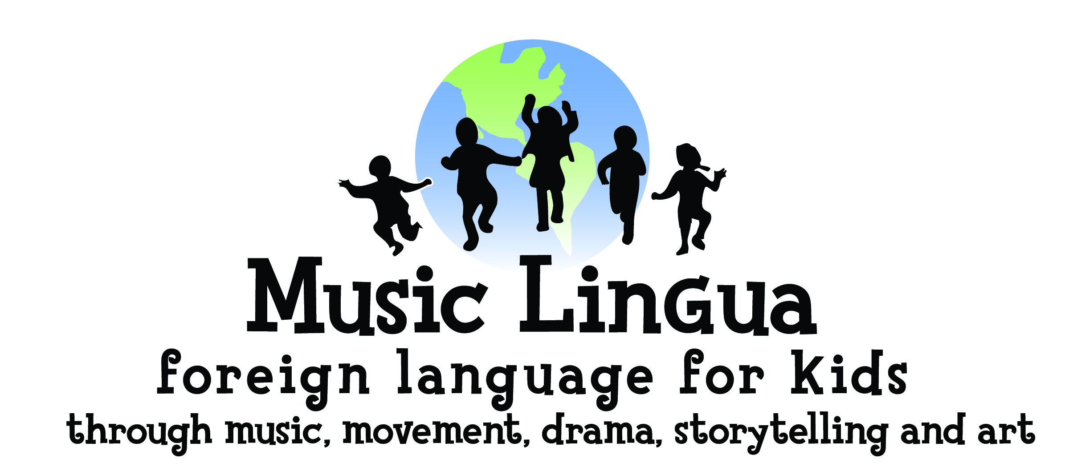
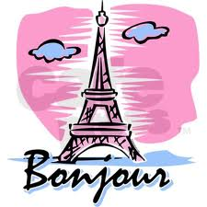

French for Kids! (ages 0-8)

10 weekly parent/child classes
Small Class Size Guaranteed

Date: Register now for spring Session starting Mar. 2020

Location: Warm Springs, NE Boise

Price: $120 for 1st child (plus $37 for take-home CDs, books & plush toy)
Only $60 for sibling!
Theme: “Transportation” 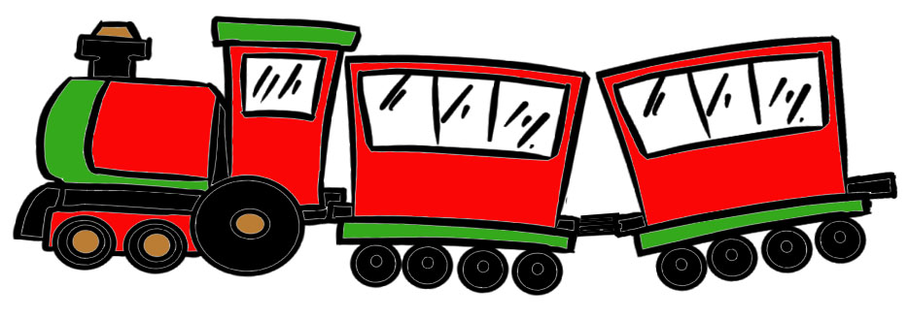

Did you know that exposure to a second language at an early age could give your child an advantage later with math and logic? Music Lingua combines the benefits of a music program with learning a foreign language in a fun, learn-through-play program.

For more details visit: www.musiclingua.com
or contact Veronica at 571-1713 or musiclingua.veronica@yahoo.com

